Credit Task 8.2 report

|  |  |
| --- | --- |
| Student Name | Lim Jia Lok |
| Student ID | 101212631 |

## SUB Task 8.2.1

#### Solution

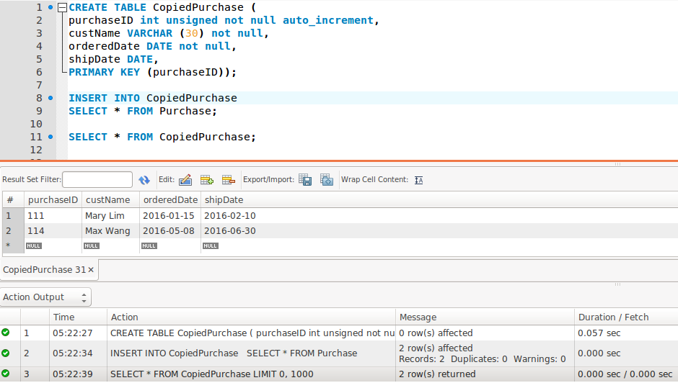

#### Comments/findings

…

(Where applicable)